SQL Query

Q1: ID’s present in ent_client but not in alert_configs

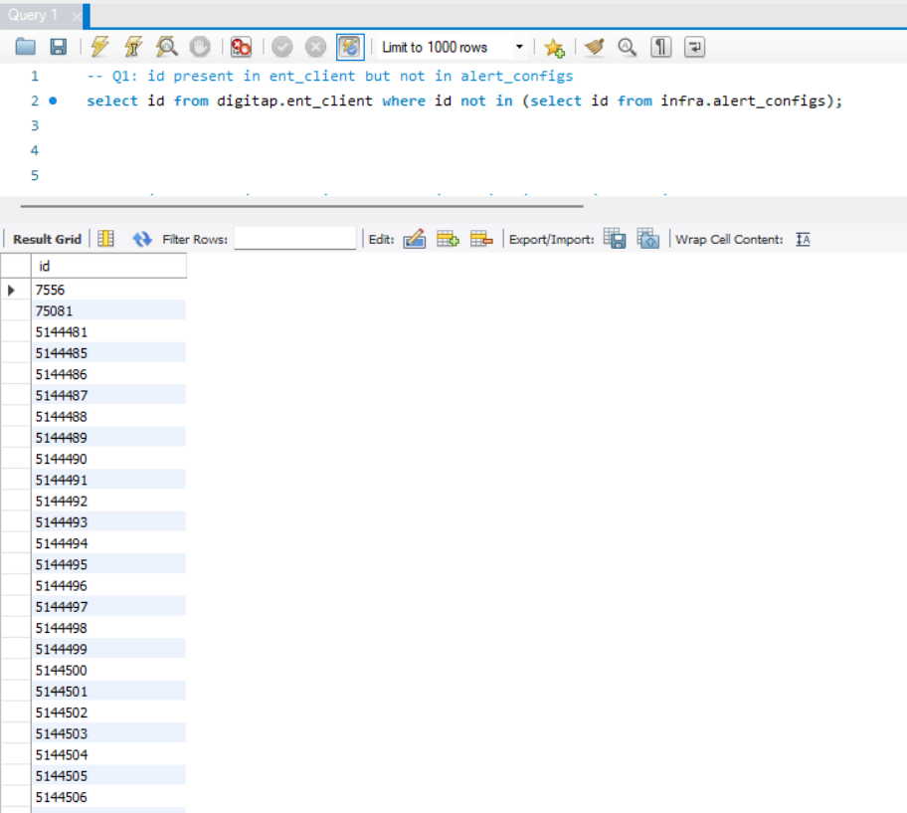

Q2: ID’s present in ent_client but not in monitoring_service_configs

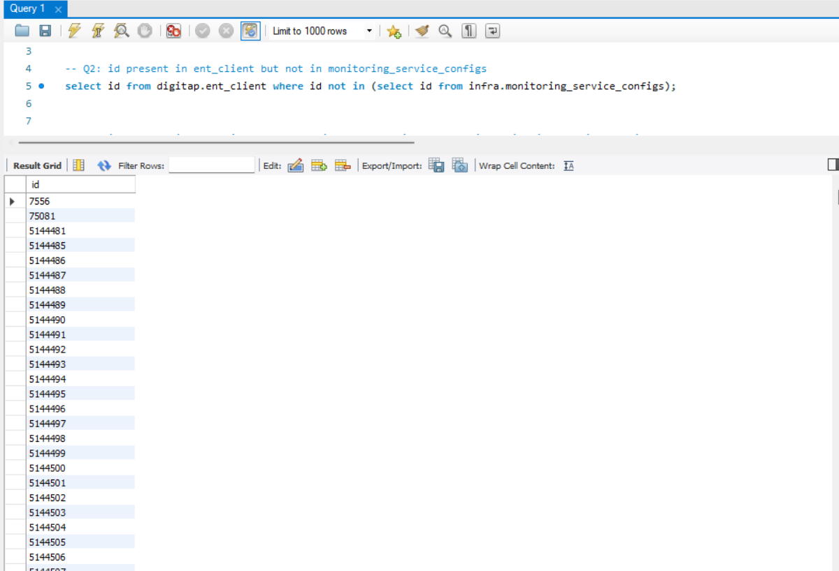

Q3: ID’s present in ent_client and present in monitoring_service_configs but not in alert_configs

